CSA1715 – ARTIFICIAL INTELLIGENCE
Analytical Problem Solving
P.SAI SWETHA
192324011
1 Problem
Measure exactly 2 gallons in the 4-gallon jug using only a 4-gallon jug, a 3-gallon jug, and a water pump.
Solution Steps
Step | 4-Gallon Jug | 3-Gallon Jug | Action
1 | 0 | 3 | Fill the 3-gallon jug.
2 | 3 | 0 | Pour all water into the 4-gallon jug.
3 | 3 | 3 | Fill the 3-gallon jug again.
4 | 4 | 2 | Pour water into the 4-gallon jug until it is full. Only 1 gallon is needed, leaving 2 gallons in the 3-gallon jug.
5 | 0 | 2 | Empty the 4-gallon jug.
6 | 2 | 0 | Pour the remaining 2 gallons from the 3-gallon jug into the 4-gallon jug.
Answer
The 4-gallon jug now contains exactly 2 gallons of water.

2 Problem

Mars Rover Agent
(i) Percepts
The rover perceives:
- Camera images
- Rocks and soil
- Temperature
- Obstacles
- Terrain
- GPS/location
- Battery level
- Sensor readings

(ii) Operating Environment
- Partially Observable
- Dynamic
- Sequential
- Stochastic
- Continuous
- Single Agent

(iii) Actions
- Move forward/backward
- Turn left/right
- Avoid obstacles
- Collect soil samples
- Analyze rocks
- Capture images
- Send data to Earth
- Recharge using solar panels

(iv) Performance Measure
Performance is evaluated by
- Number of samples collected
- Accuracy of analysis
- Distance covered
- Energy efficiency
- Successful communication
- Safety of rover
- Completion of mission

(v) Suitable Agent Architecture
Utility-Based Learning Agent
- Makes decisions based on battery life.
- Learns from previous observations.
- Chooses the safest and shortest path.
- Optimizes mission success.

3 Problem

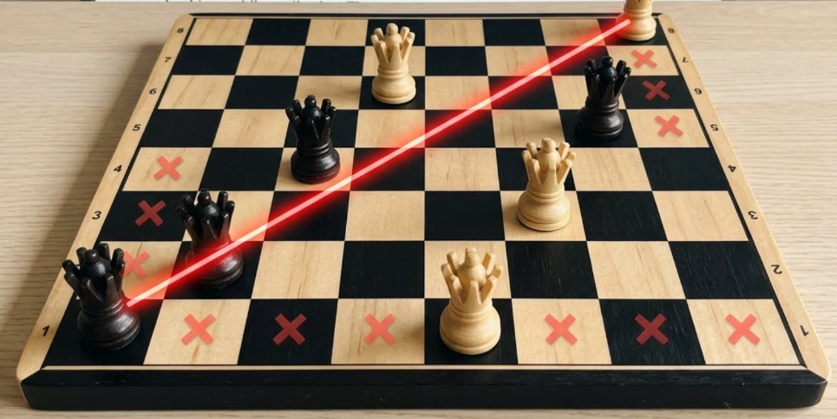

8-Queens Problem
Problem Components
Initial State
Empty 8×8 chessboard.

State Space
All possible arrangements of 8 queens.

Successor Function
Place one queen in the next column ensuring no attack.

Goal Test
No two queens attack each other.
- No same row
- No same column
- No same diagonal

Path Cost
Every move has equal cost.

Search Strategy
Backtracking Search (Depth-First Search)

Solution Representation
One valid solution is
Column | 1 | 2 | 3 | 4 | 5 | 6 | 7 | 8
Row | 1 | 5 | 8 | 6 | 3 | 7 | 2 | 4
No queens attack each other.

4 Problem

OLA Cab Booking Application
Suitable Problem Solving Agent
Goal-Based Agent
Reason:
The goal is to reach the destination while selecting the preferred cab type.

Pseudocode
START

Input source
Input destination

Display cab types
(Mini, Micro, Sedan, Prime, Shared)

User selects cab

Calculate distance

Estimate fare

Show estimated arrival time

Ask for confirmation

IF confirmed THEN
Book cab
Assign nearest driver
Send booking details
ELSE
Cancel booking
ENDIF

END

5 Problem

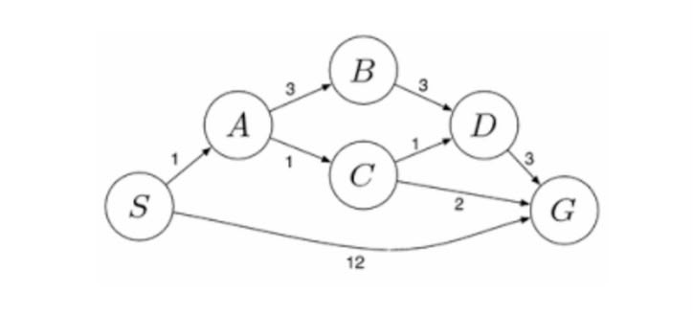

Uniform Cost Search (UCS)
Graph
Edges:
S → A = 1
S → G = 12
A → B = 3
A → C = 1
B → D = 3
C → D = 1
C → G = 2
D → G = 3

UCS Steps
Step | Node Expanded | Cost
1 | S | 0
2 | A | 1
3 | C | 2
4 | D | 3
5 | G | 4

Path Costs
- S → G = 12
- S → A → B → D → G = 10
- S → A → C → D → G = 6
- S → A → C → G = 4 (Minimum Cost)

Final Answer
Least Cost Path:
$$\boxed{S→A→C→G}$$
Total Cost:
$$\boxed{1+1+2=4}$$

